Compact Product–Activity Extraction Rules for NotebookLM
Context
The task is to reconstruct the product and procurement meaning of short DoD budget or FMS line items using only the official source library provided by the researcher.
The official source library may include DoD budget justification books, military service procurement documents, DSCA/FMS announcements, congressional notifications, and official program descriptions.
All extracted information must be grounded in the provided official sources.
Primary Task
For each line item, extract the following fields:
| Line Item Title | DoD Budget Description | Core Deliverable | Core Activity | Source URL |
Do not rely on unsupported outside knowledge.
Do not write generic encyclopedia-style descriptions.
Use the official budget or program context to recover what the line item is funding or supporting.

Field Definitions
1. Line Item Title
Keep the original line item title exactly as provided.
Do not rewrite, expand, translate, or normalize this field.
2. DoD Budget Description
Write a concise official-source-based description of what the budget item refers to.
This field should explain:
- the relevant program or weapon system,
- the supported platform if applicable,
- the procurement account or budget context if available,
- what the line item is funding or supporting.
Do not merely repeat the title.
3. Core Deliverable
Identify the main product, platform, system, component, kit, payload, munition, sensor, subsystem, or modification package represented by the line item.
Write this as a concise noun phrase.
Examples:
- MQ-1 unmanned aerial vehicle
- F-15 electronic warfare survivability upgrade package
- shipboard vertical missile launcher module
- AN/SSQ-62 active sonobuoy
- precision guidance fuze kit for 155mm artillery projectiles
- tracked multiple-launch rocket artillery system
4. Core Activity
Identify the dominant procurement or budget activity represented by the line item.
Use a concise activity phrase, such as:
- aircraft / UAV procurement
- aircraft modification / retrofit
- ship procurement
- ship modification / combat system integration
- armored vehicle procurement
- vehicle modification / upgrade
- missile / rocket system procurement
- launcher system procurement
- ammunition / ordnance procurement
- electronic system procurement
- sensor / detection equipment procurement
- communications equipment procurement
- spare parts / repair parts
- training / support equipment
- maintenance / sustainment support
- mixed package / needs review
5. Source URL
Provide the official source URL or official document reference that supports the reconstructed description, core deliverable, and core activity.
Use the most directly relevant official source first.
If no direct URL is available, provide the official document name and page, section, table, or program reference.

Extraction Rules
- Start from the original line item title and identify program names, acronyms, model numbers, weapon-system names, and procurement keywords.
- Search the provided official source library for direct matches to the title, acronym, model number, or program name.
- Use the surrounding official source context to determine the service, procurement account, supported platform, weapon system, and budget activity.
- Identify the core deliverable by asking: what product, platform, system, component, kit, payload, munition, sensor, or modification package is actually being procured, installed, modified, or supported?
- Identify the core activity by reading procurement terms such as procurement, modification, upgrade, retrofit, installation, integration, spares, repair parts, ammunition, missile, launcher, support equipment, training device, or sustainment.
- If the item is a subsystem, payload, or kit, identify the supported platform or weapon system when the source provides it.
- If the item is a modification, retrofit, installation, or integration line, identify both the installed system and the platform being modified.
- If the item is a mixed package, identify the dominant deliverable when the official source supports it. If no dominant deliverable can be identified, use “Needs review” in the relevant field.
- Do not mark an item as unclear merely because the title is short, contains an acronym, or refers to a subsystem. Use the official source context to make the best-supported interpretation.
- Use “Needs review” only when the official sources do not support a stable identification of the product, deliverable, supported platform, or dominant activity.

Formatting
Return the result as a table with exactly these fields:
| Line Item Title | DoD Budget Description | Core Deliverable | Core Activity | Source URL |
For JSON output, use:
[
{
"Line Item Title": "MQ-1 UAV",
"DoD Budget Description": "Army aircraft procurement line for MQ-1 unmanned aerial vehicle procurement or support within aviation procurement.",
"Core Deliverable": "MQ-1 unmanned aerial vehicle",
"Core Activity": "aircraft / UAV procurement",
"Source URL": "official source URL or document reference"
}
]

Compact Sector Assignment Rules for NotebookLM
Context
The input table already contains reconstructed product-and-activity fields:
| Line Item Title | DoD Budget Description | Core Deliverable | Core Activity | Source URL |
For each row, use these fields to add only two columns:
| AI_Reason | AI Suggested Sector |
The sector assignment should be based on the core deliverable and core activity, not only on the military mission or function.
Output Requirement
Add exactly two columns:
- AI_Reason
One concise sentence explaining the classification logic.
- AI Suggested Sector
Select exactly one value from:
AS001, AS002, AS003, AS004, AS005, AS006, Needs review.
Do not rewrite the original fields.
Do not add manual review columns.
Do not add NAICS or BEA columns in this step.
Sector Definitions
AS001 — Aircraft and Aircraft Systems
Use for aircraft, helicopters, UAVs, aircraft engines, aircraft parts, aircraft support equipment, and aircraft modification or retrofit.
Examples: MQ-1 UAV; MQ-9; UH-60; AH-64; F-15 aircraft modification; LAIRCM aircraft installation; F-15 EPAWSS integration.
Boundary rule:
If an electronic or survivability system is mainly installed into an aircraft as an aircraft modernization or retrofit activity, classify it as AS001 rather than AS006.
AS002 — Missiles, Rockets, and Space Launch Systems
Use for guided missiles, rocket systems, missile defense systems, rocket artillery systems, missile launchers, launch vehicles, and non-satellite space launch systems.
Examples: HIMARS; M270 MLRS; GMLRS; Patriot; THAAD; Javelin; TOW; ATACMS; standalone MK 41 VLS launcher modules; launch vehicles.
Boundary rule:
Rocket artillery systems such as MLRS and HIMARS are missile/rocket systems, not conventional artillery ammunition.
AS003 — Armored Vehicles and Tanks
Use for tanks, armored vehicles, tracked combat vehicles, armored vehicle components, and armored vehicle modification.
Examples: M1 Abrams; Bradley; Stryker; M88 recovery vehicle; armored vehicle upgrades.
Boundary rule:
Do not use AS003 for ordinary non-armored tactical trucks unless the official source identifies them as armored vehicles, tanks, or tracked combat vehicles.
AS004 — Ships and Marine Systems
Use for naval ships, submarines, shipbuilding, ship repair, ship modernization, marine propulsion, shipboard combat-system integration, and naval/marine systems.
Examples: submarines; destroyers; aircraft carrier modernization; ship repair; Automatic Carrier Landing System on carriers; MK 41 VLS ship installation; Phalanx CIWS shipboard upgrade; unmanned underwater vehicles.
Boundary rule:
If a weapon, launcher, sensor, radar, sonar, or landing system is mainly installed into or integrated with a ship, classify it as AS004.
AS005 — Ammunition and Ordnance
Use for ammunition, artillery rounds, mortar rounds, bombs, torpedoes, naval mines, fuzes, warheads, munition kits, and expendable ordnance.
Examples: 155mm artillery rounds; M1156 Precision Guidance Kit; naval mines; MK 54 torpedo; bombs; tank ammunition; fuzes; warheads.
Boundary rule:
If a kit is designed exclusively to become part of an artillery projectile or munition, classify it as AS005 even if it contains guidance electronics.
AS006 — Electronic Equipment, Sensors, Communications, and Detection Systems
Use for standalone military electronics, communications equipment, radar, sonar, sonobuoys, navigation equipment, detection systems, electronic warfare systems, ISR sensors, EO/IR sensors, antennas, signal-processing equipment, and military satellites when mapped to communications/electronic equipment.
Examples: AN/SSQ-62 DICASS; standalone radar; standalone sonar; communications equipment; military satellite; standalone EW equipment; ISR sensor payload.
Boundary rule:
If the electronic system is standalone, use AS006. If it is mainly part of aircraft, ship, or vehicle modification, classify by the supported platform instead.
General Decision Rules
- Classify by Core Deliverable + Core Activity.
- Do not classify by military mission alone.
- If the item is platform modification, retrofit, installation, or integration, classify by the supported platform.
- If the item is standalone equipment, classify by the standalone deliverable.
- If the item is a mixed package, classify by the dominant product or primary budget purpose.
- Use Needs review only when the existing fields do not support a stable assignment.
Formatting
Return the original table with exactly two added columns:
| Line Item Title | DoD Budget Description | Core Deliverable | Core Activity | Source URL | AI_Reason | AI Suggested Sector |

Source URL:

Source group | Examples | Coverage
DoD budget justification books | Army/Navy/Air Force procurement books | aircraft, missiles, ammunition
DSCA/FMS notices | FMS congressional notifications | foreign military sales
Official program documents | weapon system descriptions | system identification

https://www.asafm.army.mil/Portals/72/Documents/BudgetMaterial/2025/Base%20Budget/Procurement/Procurement-of-Ammunition-Army.pdf
https://www.asafm.army.mil/Portals/72/Documents/BudgetMaterial/2025/Base%20Budget/Procurement/Other%20Procurement%20-%20BA%201%20-%20Tactical%26Support%20Vehicles.pdf
https://www.asafm.army.mil/Portals/72/Documents/BudgetMaterial/2025/Base%20Budget/Procurement/Other%20Procurement%20-%20BA%202%20-%20Communications%20and%20Electronics.pdf
https://www.asafm.army.mil/Portals/72/Documents/BudgetMaterial/2025/Base%20Budget/Procurement/Other%20Procurement%20-%20BA%203%20%26%204%20-%20Other%20Support%20Vehicles.pdf
https://www.secnav.navy.mil/fmc/fmb/Documents/25pres/APN_BA1-4_Book.pdf
https://www.secnav.navy.mil/fmc/fmb/Documents/25pres/PMC_Book.pdf
https://comptroller.war.gov/Portals/45/Documents/defbudget/FY2026/budget_justification/pdfs/02_Procurement/PROC_MDA_VOL2B_PB_2026.pdf
https://comptroller.war.gov/Portals/45/Documents/defbudget/fy2010/FY2010_Weapons.pdf
https://comptroller.war.gov/Portals/45/Documents/defbudget/fy2011/budget_justification/pdfs/02_Procurement/SOCOM_PDW_PB11.pdf
https://www.asafm.army.mil/Portals/72/Documents/BudgetMaterial/2010/base%20budget/justification%20book/wtcv.pdf
https://www.asafm.army.mil/Portals/72/Documents/BudgetMaterial/2011/base%20budget/justification%20book/ammo.pdf
https://www.asafm.army.mil/Portals/72/Documents/BudgetMaterial/2025/Base%20Budget/Procurement/Aircraft-Procurement-Army.pdf
https://www.asafm.army.mil/Portals/72/Documents/BudgetMaterial/2025/Base%20Budget/Procurement/Missile-Procurement-Army.pdf
https://www.asafm.army.mil/Portals/72/Documents/BudgetMaterial/2026/Discretionary%20Budget/Procurement/Other%20Procurement%20-%20BA1%20-%20Tactical%20%26%20Support%20Vehicles.pdf
https://www.saffm.hq.af.mil/Portals/84/documents/FY13/AFD-120207-049.pdf?ver=2016-08-24-090009-980
https://www.secnav.navy.mil/fmc/fmb/Documents/25pres/OPN_BA1_Book.pdf
https://comptroller.defense.gov/portals/45/documents/defbudget/fy2008/fy2008_weabook.pdf
https://comptroller.defense.gov/Portals/45/Documents/defbudget/fy2009/budget_justification/pdfs/02_Procurement/Vol_2_SOCOM_CBDP/SOCOM%20PDW%20PB09.pdf
https://www.saffm.hq.af.mil/FM-Resources/Budget/Air-Force-Presidents-Budget-FY08/
https://www.saffm.hq.af.mil/Portals/84/documents/FY09/AFD-080204-085.pdf?ver=2016-08-22-141541-383
https://comptroller.defense.gov/Portals/45/documents/fmr/current/02b/02b_04.pdf
https://comptroller.defense.gov/Portals/45/Documents/defbudget/docs/fy2004_weabook.pdf
https://www.saffm.hq.af.mil/Portals/84/documents/FY07/AFD-070214-050.pdf
https://www.asafm.army.mil/Portals/72/Documents/BudgetMaterial/2026/Discretionary%20Budget/Procurement/Procurement%20of%20Weapons%20and%20Tracked%20Combat%20Vehicles.pdf
https://www.asafm.army.mil/Budget-Materials/
https://www.secnav.navy.mil/fmc/fmb/Documents/26pres/WPN_Book.pdf
https://www.secnav.navy.mil/fmc/fmb/Documents/26pres/APN_BA6-7_Book.pdf
https://comptroller.defense.gov/Budget-Materials/Budget2025/
https://www.saffm.hq.af.mil/FM-Resources/Budget/

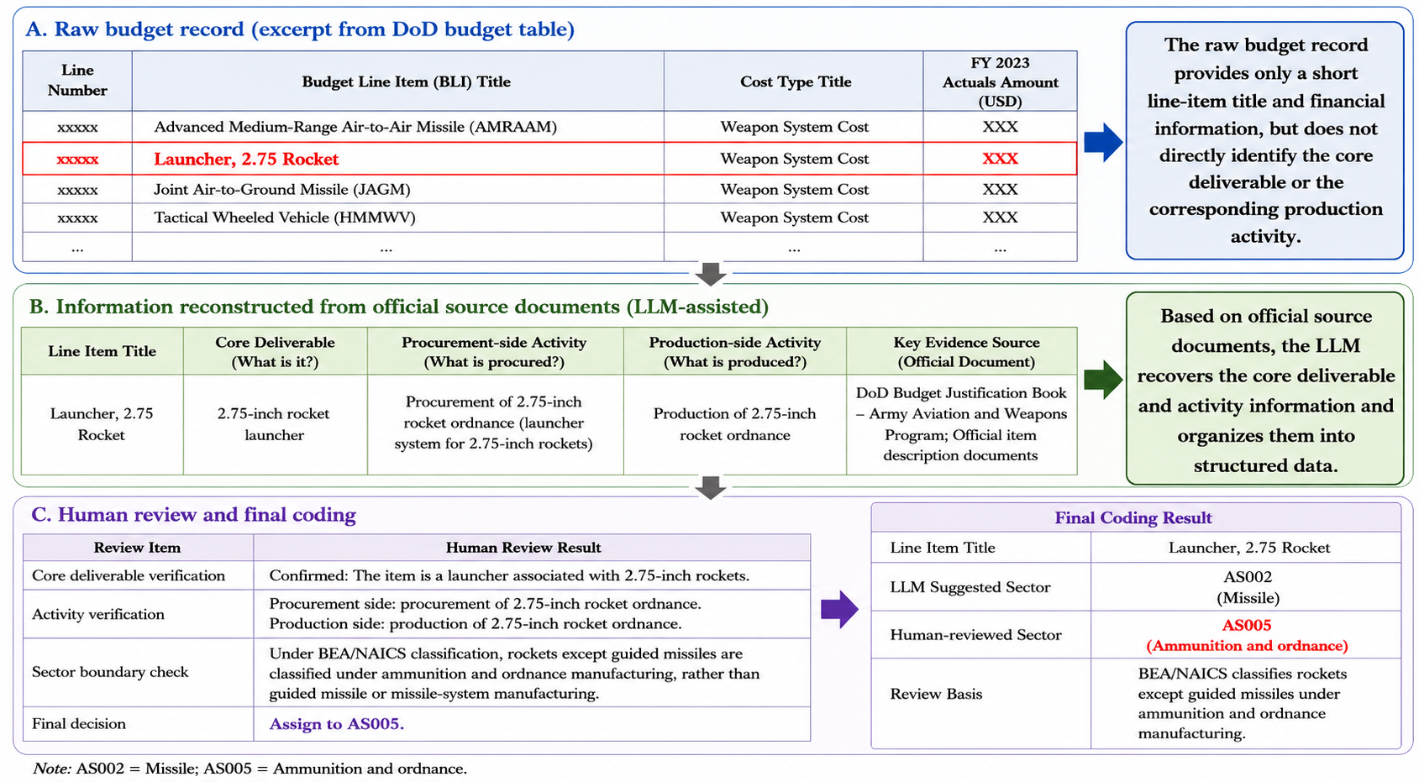
Figure 1: Illustrative example of line-item reconstruction and final sector codin

